 | 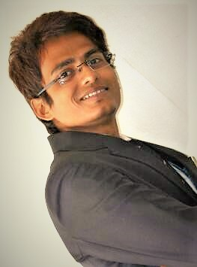
  Name | : | Anirban Mondal
  Date of Birth | : | 25-07-1989
  E-mail | : | anirbanmondaldic@gmail.com
  Mobile Number | : | +91-9836860754

OBJECTIVE

Put my skills to work and contribute for the development and benefit of the organization, the self and the society.

SCHOLASTIC RECORD

Degree | School / College / University | Year | Percentage
PGDM/MBA | Pune University | 2016 | Pursuing
B.A. | Calcutta University | 2013 | 50%
XII | W.B.C.H.S.E | 2007 | 62%
X | W.B.B.S.E | 2005 | 66%

KEY SKILLS AND CAPABILITIES

- Eager to learn new things.
- Learn from mistakes.
- Stand in difficult situation boldly.
- Accept new change quickly.
- Communicate very easily and reply.
- Judge the problem as soon as possible and find out solutions.
- Love to play with words.

POSITIONS OF RESPONSIBILITY

Bachelor’s | - Part of musical events organizing in college fests.  - Lead Vocalist of an English Rock Metal Band.
OSITIONS OF RESPONSIBILITY

OTHER ACTIVITIES AND ACHIEVEMENTS

Co-curricular Activities | - Lead Anchor of the promotional activity of Samsung Galaxy Note II at Ranchi (J.D. High Street Mall).  - Leading a Rock Metal Band since 3 years named Hell Racer.  - Participated in a few concerts.

OTHER INTERESTS / HOBBIES

- Listening to Music.
- Singing.
- Sketching, making portraits and sculptures.
- Writing poems & articles.
- Researching on Paranormal Activities.
- Playing Chess, Carom, PC Games, Table Tennis.
- Interacting with people and gaining new knowledge.
- Surfing Wikipedia.

INTERNSHIP & PROFESSIONAL CAREER

- Internship at Kajaria Ceramics.
One month internship on Ceramics Galaxy.

- Internship at Studio Red.
Two months internship as a Recruiter & Management Trainee.

- Worked as an Abroad Education Counselor at BSB International Career Pvt. Ltd. from September 2014 - December 2014.

- Worked at Infocom Network Ltd. (Trade India) as a Sr. Business Developer from August 2015 – October 2015.

- Worked at Gateway Abroad since March 2016 to June 2016 as an Asst. Manager – Business Expansion.

- Freelance Writer since 2012.

CONTACT INFORMATION

Permanent Address | : | ½,Rasapunja, Charaktala,  Thakurpukur,  Kolkata- 700104
I hereby acknowledge that the above furnished details are true to the best of my knowledge.

ANIRBAN MONDAL

